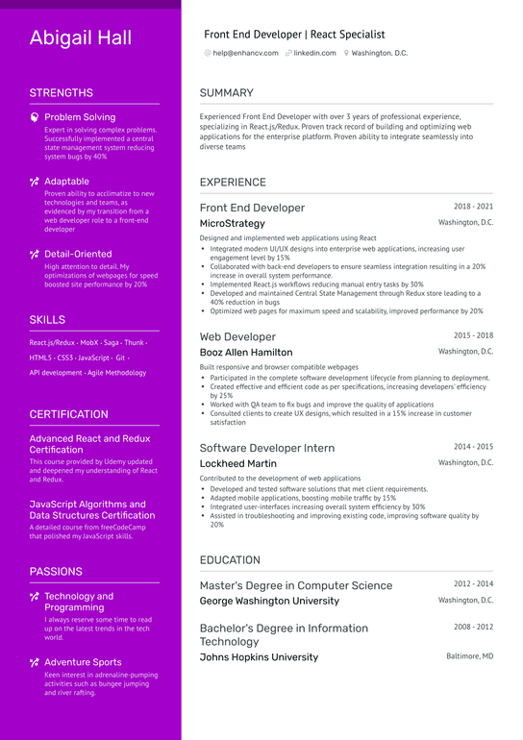
Abigail Hall
Front End Developer | React Specialist
@help@enhancv.com linkedin.com Washington, D.C.
STRENGTHS
Problem Solving
Expert in solving complex problems. Successfully implemented a central state management system reducing system bugs by 40%
• Adaptable
Proven ability to acclimatize to new technologies and teams, as evidenced by my transition from a web developer role to a front-end developer
Detail-Oriented
High attention to detail. My
optimizations of webpages for speed boosted site performance by 20%
SKILLS
React.js/Redux MobX-Saga-Thunk. HTML5 CSS3 JavaScript. Git. API development - Agile Methodology
CERTIFICATION
Advanced React and Redux Certification
This course provided by Udemy updated and deepened my understanding of React and Redux.
JavaScript Algorithms and Data Structures Certification A detailed course from freeCodeCamp that polished my JavaScript skills.
SUMMARY
Experienced Front End Developer with over 3 years of professional experience, specializing in React.js/Redux. Proven track record of building and optimizing web applications for the enterprise platform. Proven ability to integrate seamlessly into diverse teams
EXPERIENCE
Front End Developer
MicroStrategy
Designed and implemented web applications using React
2018-2021
Washington, D.C.
• Integrated modern UI/UX designs into enterprise web applications, increasing user engagement level by 15%
• Collaborated with back-end developers to ensure seamless integration resulting in a 20% increase in overall system performance.
• Implemented Reactjs workflows reducing manual entry tasks by 30%
•Developed and maintained Central State Management through Redux store leading to a 40% reduction in bugs
• Optimized web pages for maximum speed and scalability, improved performance by 20%
Web Developer
Booz Allen Hamilton
Built responsive and browser compatible webpages
2015-2018 Washington, DC.
• Participated in the complete software development lifecycle from planning to deployment.
• Created effective and efficient code as per specifications, increasing developers' efficiency by 25%
• Worked with QA team to fix bugs and improve the quality of applications
• Consulted clients to create UX designs, which resulted in a 15% increase in customer satisfaction
Software Developer Intern
Lockheed Martin
Contributed to the development of web applications
• Developed and tested software solutions that met client requirements.
• Adapted mobile applications, boosting mobile traffic by 15%
• Integrated user-interfaces increasing overall system efficiency by 30%
2014-2015 Washington, DC.
• Assisted in troubleshooting and improving existing code, improving software quality by 20%
EDUCATION
PASSIONS
Technology and Programming
I always reserve some time to read
up on the latest trends in the tech world.
Adventure Sports
Keen interest in adrenaline-pumping activities such as bungee jumping and river rafting.
Master's Degree in Computer Science
2012-2014
George Washington University
Washington, D.C.
Bachelor's Degree in Information
2008-2012
Technology
Johns Hopkins University
Baltimore, MD

